
Research Article
Prevalence of knee osteoarthritis among males and females in rural area using ACR criteria: an observational cross-sectional study

Lalita Khandalikar, Vibhuti Patil*, Nilesh Dond, Deepak Anap
Dee
Department of Musculoskeletal Sciences, DVVPF’S College of Physiotherapy, Ahmednagar, Maharashtra, India

Corresponding author: Vibhuti Patil, vibhutipatil1714@gmail.com, Orcid Id: https://orcid.org/0009-0007-1450-5244
© The author(s). This is an open access article distributed under the terms of the Creative Commons Attribution License (https://creativecommons.org/licenses/by-nc/4.0/). See https://ijtinnovation.com/reprints-and-permissions for full terms and conditions.

Received - 12-06-2026, Revised - 15-07-2026, Accepted - 10-08-2026 (DD-MM-YYYY)
Refer this article
Lalita Khandalikar, Vibhuti Patil, Nilesh Dond, Deepak Anap, Prevalence of knee osteoarthritis among males and females in rural area using ACR criteria: an observational cross-sectional study, Journal of Health Physiotherapy and Orthopaedics. July-August 2026, V 3 - I 4, Pages - 10 – 14. Doi: https://doi.org/10.55522/jhpo.V3I4.0080.

ABSTRACT
Knee osteoarthritis (OA) is a common joint problem that causes pain, stiffness, and trouble in walking, especially in older people. It mostly affects women and is often linked with age and obesity. Knowing how common OA is can help in early treatment and prevention. Hence, the purpose of this study was to determine the prevalence of knee osteoarthritis among the selected population and to analyze its association with risk factors such as age, gender, and body mass index (BMI). This study was done on 100 people from a rural area. Out of them, 60 had knee OA (positive ACR criteria) and 40 did not have OA (negative ACR). Information about age, gender, BMI, and symptoms like pain, stiffness, and swelling was collected and studied. Out of 100 participants, 34 (34%) were males and 66 (66%) were females, showing that females had a higher number of knee OA cases. The most affected age group was 61–70 years (33%), followed by 51–60years (20%). According to ACR criteria, 60 participants (60%) had knee OA, and 40 (40%) were negative for OA. Common symptoms among those with OA were knee pain (60%), morning stiffness (60%), and bony tenderness (60%). Crepitus was present in 46%, bony enlargement in 23%, and no palpable warmth in 30% of participants.
Based on BMI, 38% were Obese Class I, 27% were Overweight, and 28% were in the Normal range, showing a strong link between obesity and knee OA. Obesity was more common among females. The study showed that knee osteoarthritis is more common in females (66%) than in males (34%), especially in older adults aged 61–70 years. Higher BMI was strongly linked to OA, showing that obesity increases the risk. The findings highlight the importance of early detection, weight control, lifestyle changes, and physiotherapy to reduce the risk and manage symptoms, especially among women in rural areas.
Keywords: Knee osteoarthritis, Prevalence, Gender differences, BMI, ACR criteria, Physiotherapy.
INTRODUCTION

Knee osteoarthritis (OA) is a common problem where the knee joint gets worn out over time. This can cause pain, stiffness, and difficulty moving. Many older people have knee OA, and it can make daily activities hard. People who live in rural areas might have more knee problems because they often do hard work that puts stress on their knees. Also, some people who are overweight or obese have more chances of getting knee OA because extra weight hurts joints.This study looks at how common knee OA is among men and women in a rural area. It also checks their symptoms and body weight to understand how these things affect knee 0A. The goal is to help find ways to prevent and manage knee problems in rural communities ^{[1-3]}.
Osteoarthritis (OA) is the most common form of arthritis and a leading cause of disability in older adults worldwide. It is a chronic, degenerative joint disease that primarily affects the articular cartilage and surrounding tissues, leading to pain, stiffness, and reduced mobility. Among the various joints affected, the knee joint is one of the most frequently involved, especially in aging populations. The prevalence of knee OA is influenced by several risk factors, including age, gender, obesity, genetics, joint injury, and occupational stress. Studies have consistently shown that females are more commonly affected than males, particularly after menopause ^{[4]}.
In rural populations, lack of healthcare access, manual labor, and delayed diagnosis may contribute to more severe presentations of the disease ^{[5]}.
Knee osteoarthritis is typically the result of wear and tear and progressive loss of articular cartilage, most common in elderly individuals. Primary OA refers to articular degeneration without any apparent cause, while secondary OA results from abnormal forces or previous trauma ^{[6]}.
The global burden of knee OA is increasing with age and improved life expectancy. Literature shows a higher prevalence and incidence of knee pain women than men, both in developing and developed countries ^{[7]}.
Advanced stages of OA can significantly impair daily functioning and quality of life. Therefore, understanding gender-based differences in the prevalence and clinical presentation of OA is crucial. The study of gender differences in OA may also provide insights into underlying disease mechanisms, as women are more commonly affected by knee and hand OA, particularly after the age of 50 ^{[8]}.
Occupational factors play an important role as well. Knee OA is a leading cause of disability and reduced quality of life, particularly among individuals engaged in physically demanding occupations such as agriculture. Agricultural work involves repetitive squatting, kneeling, heavy lifting, and prolonged standing, which increase stress on the knee joints these factors, combined with biological and socio-cultural aspects, may explain why rural women—often engaged in both fieldwork and household chores—report higher rates of OA than men.This study, therefore, aims to assess the prevalence of knee osteoarthritis among males and females in a rural area, and to evaluate clinical features based on the American college of rheumatology (ACR) criteria, with a focus on how body weight and occupation contribute to the condition. The findings aim to highlight the burden of knee OA in underserved populations and emphasize the need for early detection and community-level interventions ^{[9]}.
Knee osteoarthritis (OA) is a common degenerative joint disease that affects mobility and quality of life, especially among the elderly. Rural agricultural workers are at higher risk due to physically demanding tasks like squatting, lifting, and prolonged standing, combined with limited access to healthcare. Studying the prevalence of knee OA among males and females in these communities helps identify gender-specific differences, understand occupational risks, and guide early interventions to improve health and wellbeing ^{[10]}.
MATERIAL AND METHODS
This study was designed as an observational cross-sectional study and was conducted in a tertiary care hospital over a period of six months. A total of 100 participants diagnosed with knee osteoarthritis (OA) were included in the study. Participants were selected using a purposive sampling technique to ensure that individuals who met the predefined eligibility criteria were systematically recruited during the study period.
The inclusion criteria comprised agricultural workers aged 40 years and above, including both males and females, who had been diagnosed with knee OA according to the criteria established by the American College of Rheumatology (ACR). Only those fulfilling the recommended clinical and/or radiological diagnostic standards were considered eligible.
Participants were excluded if they had undergone recent knee or lower limb surgery, had a history of ligament injury or fractures around the knee joint, or had diagnosed psychological disorders that could interfere with assessment and participation. These criteria were applied to ensure homogeneity of the study population and to minimize potential confounding factors that might have influenced the study outcomes.
RESULTS
Table 1: Gender Distribution
 | Males | Females | Both (Total)
ACR – Negative (No OA) | 15 (15%) | 25 (25%) | 40 (40%)
ACR Positive | 19(19) % | 41(41) % | 60(60%)

Out of a total of 100 participants in the study, 60% were found to have knee osteoarthritis (OA) according to the ACR criteria, while 40% did not have OA. Among the males, 19% were ACR criteria positive (had OA), and 15% were ACR criteria negative (did not have OA). This shows that fewer men were affected by OA compared to women.Among the females, 41% were ACR criteria positive and 25% were ACR criteria negative. This means that knee OA was more common among females in the rural area. Overall, the results indicate that females (41%) were more affected by knee OA than males (19%), showing a higher prevalence of knee osteoarthritis among women in the studied rural population.
Pie Chart 1: Distribution of spine conditions
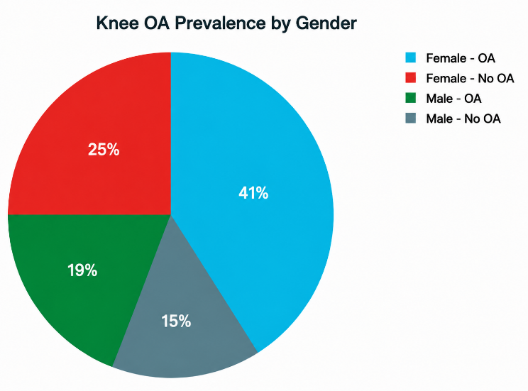

Table 2: Distribution of participants according to age groups
Age Group (years) | N | %
40–50 | 16 | 16.0%
51–60 | 20 | 20.0%
61–70 | 33 | 33.0%
71–80 | 11 | 11.0%
80 and above | 2 | 2.0%
40–45 (from ACR-negative group) | 18 | 18.0%

In this study, a total of 100 participants were included. Among them, 16 people (16%) were between the ages of 40 to 50 years, and 20 people (20%) were in the 51 to 60 years age group. The highest number of participants, 33 people (33%), were between 61 to 70 years, showing that most of the participants were older adults. There were also 11 participants (11%) in the 71 to 80 years group and only 2 participants (2%) who were above 80 years of age. In addition, from the ACR-negative group (those without osteoarthritis), 18 participants (18%) were between 40 to 45 years. This clearly shows that knee osteoarthritis was more common among the older age groups, especially between 61 to 70 years, while younger participants (40–45 years) mostly did not have osteoarthritis.
Pie Chart 2: (Age wise distribution of knee OA)
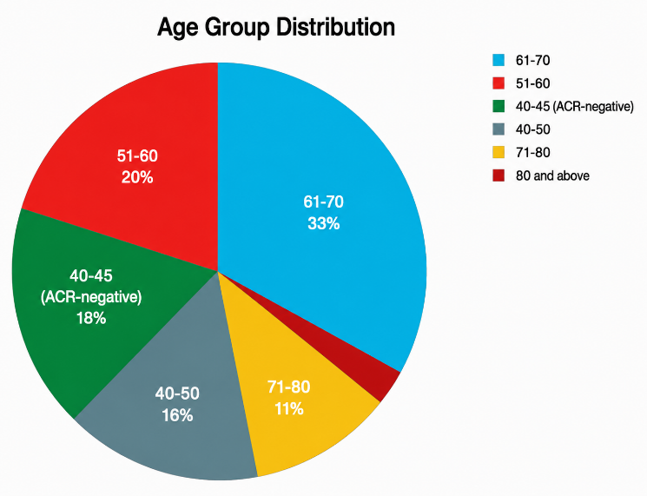

Table 3: Prevalence and Knee OA
ACR Criteria | Males N (%) | Females N (%) | Total N (%)
ACR – Knee Pain | 19 (19%) | 41 (41%) | 60 (60%)
ACR – Morning Stiffness < 30 min | 19 (19%) | 41 (41%) | 60 (60%)
ACR – Bony Tenderness | 19 (19%) | 41 (41%) | 60 (60%)
ACR – Crepitus | 14 (14%) | 32 (32%) | 46 (46%)
ACR – Bony Enlargement | 5 (5%) | 18 (18%) | 23 (23%)
ACR – No Palpable Warmth | 8 (8%) | 22 (22%) | 30 (30%)
ACR – Negative (No OA) | 15 (15%) | 25 (25%) | 40 (40%)

In this study, out of 100 participants, 60 people (60%) had knee pain, with 19 males (19%) and 41 females (41%) affected. The same number of participants, 60 (60%), also reported morning stiffness lasting less than 30 minutes, showing that stiffness was a common complaint in both men and women. Bony tenderness was also found in 60 participants (60%), again with 19 males and 41 females, which means tenderness around the joint was very frequent.Crepitus, or a crackling sound in the knee, was noticed in 46 people (46%), including 14 males (14%) and 32 females (32%). Bony enlargement, which is a sign of joint changes, was seen in 23 people (23%) — 5 males (5%) and 18 females (18%). No palpable warmth was observed in 30 participants (30%), which included 8 males (8%) and 22 females (22%), showing that most had no signs of active inflammation. Finally, 40 participants (40%) were ACR-negative, meaning they did not have knee osteoarthritis; this group had 15 males (15%) and 25 females (25%). Overall, the findings show that female participants had higher rates of all ACR symptoms compared to males, and knee osteoarthritis was more commonly seen among women.

Figure 1: Graph showing Gender wise ACR findings
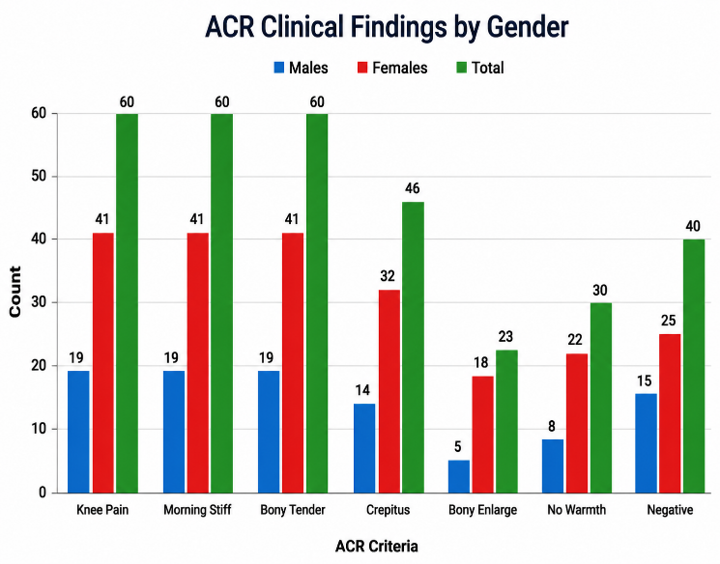

Distribution Of Participants According to BMI
Table 4: BMI Range (Kg/m²)
BMI Range (Kg/m²) | Category | Males N (%) | Females N (%) | Total N (%)
< 18.5 | Underweight | 1 (1%) | 1 (1%) | 2 (2%)
18.5 – 24.9 | Normal (Healthy Weight) | 8 (8%) | 20 (20%) | 28 (28%)
25.0 – 29.9 | Overweight | 16 (16%) | 11 (11%) | 27 (27%)
30.0 – 34.9 | Obese Class I (Moderate) | 12 (12%) | 26 (26%) | 38 (38%)
35.0 – 39.9 | Obese Class II (Severe) | 2 (2%) | 4 (4%) | 6 (6%)
≥ 40.0 | Obese Class III (Very Severe) | 0 (0%) | 0 (0%) | 0 (0%)
Total |  | 34 (34%) | 66 (66%) | 100 (100%)
Figure 2: Distribution of other specific conditions
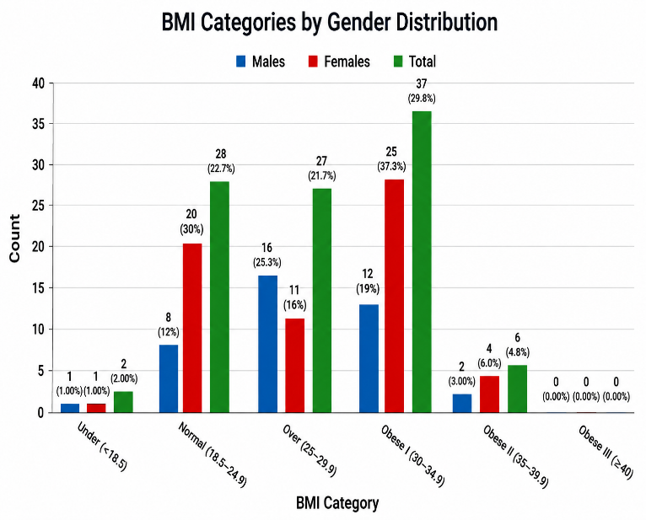
In this study, most participants had a higher body weight compared to the normal range. Only 2 people (2%) were underweighted, with 1 male (1%) and 1 female (1%). A total of 28 participants (28%) had a normal BMI (18.5–24.9), which included 8 males (8%) and 20 females (20%), showing that a small portion of the group had a healthy weight.The overweight category (25.0–29.9) included 27 participants (27%), with 16 males (16%) and 11 females (11%). The largest group was in the Obese Class I (30.0–34.9) category, where 38 participants (38%) were found — 12 males (12%) and 26 females (26%). This shows that moderate obesity was quite common in this group.A smaller number of people, 6 participants (6%), were in the Obese Class II (35.0–39.9) range, including 2 males (2%) and 4 females (4%), indicating severe obesity. No one was found in the Obese Class III (≥ 40.0) group. Overall, these results show that most participants were either overweight or obese, and obesity was more common among females than males. This suggests that excess body weight could be an important factor related to knee problems in this study ^{[11]}.
DISCUSSION
The present study assessed the prevalence of knee osteoarthritis (OA) among males and females in a rural population and analyzed its association with age and body mass index (BMI). The overall prevalence of knee OA based on ACR criteria in the current study was 60%, which indicates a considerable burden in the rural population. Similar rural-based Indian studies have also reported a high prevalence of knee OA among adults above 40 years. These findings suggest that rural populations, particularly those involved in manual labour, are at increased risk.
In this study, females (41%) were more affected than males (19%), demonstrating a higher prevalence among women. This finding is consistent with the meta-analysis by Srikanth et al, which reported significantly higher prevalence, incidence, and severity of knee OA in females compared to males, especially after the age of 50 years.
Indian studies have also confirmed greater susceptibility among females due to menopausal hormonal changes, decreased muscle strength, and sociocultural factors. Hormonal influence, particularly reduced estrogen levels after menopause, is considered an important contributing factor in cartilage degeneration and disease progression. Therefore, the present findings align with previous national and international evidence.
The majority of affected participants in this study belonged to the 61–70 years age group (33%), confirming that OA prevalence increases with advancing age. Classical epidemiological studies have consistently identified age as the strongest non-modifiable risk factor for knee OA. Degenerative changes such as progressive cartilage wear, subchondral bone remodelling, and osteophyte formation explain this increased prevalence in older adults. Similar age-wise distribution has been reported in other rural Indian studies, supporting the current findings.
Among ACR-positive participants, knee pain, morning stiffness (<30 minutes), and bony tenderness were present in 60% of cases, while crepitus (46%) and bony enlargement (23%) were less frequent. These findings are comparable to previous community-based studies where pain and short-duration stiffness were dominant symptoms. The absence of palpable warmth in 30% of cases further supports the degenerative and non-inflammatory nature of osteoarthritis, differentiating it from inflammatory joint disorders.
The study showed that a large proportion of participants were overweight (27%) or obese (44% combined Class I & II), and obesity was more common among females. Several studies have demonstrated a strong association between high BMI and knee OA severity. Agricultural work involves repetitive squatting, kneeling, prolonged standing, and heavy lifting, which significantly increase tibiofemoral joint stress. Occupational risk factor studies among rural agricultural workers have also shown higher OA prevalence in physically demanding professions. These findings are consistent with the present study results and indicate that mechanical stress plays a significant etiological role. According to the World Health Organization, obesity increases mechanical loading on weight-bearing joints, accelerating cartilage breakdown.
Biomechanically, each additional kilogram of body weight increases compressive forces across the knee joint during ambulation, thereby increasing the risk of degeneration. Similar associations between BMI and knee OA have been documented in rural population studies.
Agricultural work involves repetitive squatting, kneeling, prolonged standing, and heavy lifting, which significantly increase tibiofemoral joint stress. Occupational risk factor studies among rural agricultural workers have also shown higher OA prevalence in physically demanding professions. These findings are consistent with the present study results and indicate that mechanical stress plays a significant etiological role ^{[12]}.
CONCLUSION
The present study concludes that knee osteoarthritis is more prevalent in older adults and females. Out of 100 participants, 66% females and 34% males were affected, showing a higher prevalence in females. Most of the affected individuals were in the 61–70 years age group (33%), and 60% of all participants had positive ACR findings for OA. BMI findings showed that 65% of the participants were either overweight or obese, indicating that excess body weight increases the pressure on the knee joints and leads to degeneration.
Limitations
This study has a few limitations. The number of participants was small, so the results may not represent the whole rural population. It was done only in one area, so people from other regions might have different results. The study relied on clinical findings without X-ray confirmation, which could have provided a clearer picture of knee OA severity. Some information, such as morning stiffness and pain, was based on self-report, so there may be small errors. Factors like daily activity, type of work, and food habits were not included, even though they can affect knee problems. Also, only BMI was used to check obesity, but other measures could show body fat more accurately. For these reasons, the findings should be understood carefully.

Future scope
In the future, similar studies can be done on a larger number of people from different rural and urban areas to get a clearer idea about how common knee osteoarthritis is. Including X-rays and other tests can help to confirm the diagnosis more accurately. Studies can also look at the effect of daily activities, type of work, and lifestyle habits like diet and exercise on knee problems. Health education programs can be planned in rural areas to increase awareness about maintaining a healthy weight and protecting joint health. Regular screening and early treatment can help reduce the number of people suffering from knee osteoarthritis in the future.
Conflict of interest
The authors declared that they have no conflict of interest among them.
Funding
Nil
REFERENCES
- Venkatachalam J, Natesan M, Eswaran M, et al, 2018. Prevalence of osteoarthritis of knee joint among adult population in a rural area of Kanchipuram district, Tamil Nadu. Indian J Public Health. 62(2):117–122. Doi: 10.4103/ijph.IJPH_344_16.
- Kiran Bala, Shalli Bavoria, Bhavna Sahni, et al, 2020. Prevalence, risk factors, and health-seeking behaviour for knee osteoarthritis among adult population in rural Jammu – a community-based cross-sectional study. J Family Med Prim Care. 9(12), Pages 6165–6170. Doi: 10.4103/jfmpc.jfmpc_643_20.
- Saravanan Kandasamy, Rajalakshmi Vadivelu, Sathish Kumar Shanmugam, 2024. Exploring the burden of knee osteoarthritis in rural South India: community prevalence, risk factors, and functional assessment among adults aged 40 and above. Cureus. Doi: 10.7759/cureus.73452.
- Srikanth VK, Fryer JL, Zhai G, et al, 2005. A meta-analysis of sex differences in prevalence, incidence and severity of osteoarthritis. Osteoarthritis Cartilage. 13(9), Pages 769–781. Doi: 10.1016/j.joca.2005.04.014.
- Sharma P, Mehta R, Kulkarni S, 2020. Prevalence of knee osteoarthritis among adults in rural India. Int J Orthop Res. 6(2), Pages 145–152. Doi: https://orcid.org/0009-0001-5784-4242.
- Gupta N, Sharma D, Bansal P, 2021. Association of body mass index and severity of knee osteoarthritis in rural populations. Indian J Community Health. 2021;33(1):67–74. Doi: 10.1136/bmjopen-2014-007568.
- Patel R, Singh H, Deshmukh V, et al, 2021. Occupational risk factors and gender differences in knee osteoarthritis among agricultural workers. J Musculoskelet Res. 24(4), Pages 389–396. Doi: https://doi.org/10.3390/healthcare14070928.
- Singh S, Prasad M, Nair A, 2022. Comparative study of knee osteoarthritis in rural and urban populations. Asian J Orthop. 8(1), Pages 102–109. Doi: 10.1016/j.joca.2022.05.004.
- Felson DT, Zhang Y, 1998. An update on the epidemiology of knee and hip osteoarthritis with a view to prevention. Arthritis Rheum. 1998;41(8):1343–1355. Doi: 10.1002/1529-0131(199808)41:8<1343::AID-ART3>3.0.CO;2-9.
- Lawrence RC, Felson DT, Helmick CG, et al, 2008. Estimates of the prevalence of arthritis and other rheumatic conditions in the United States. Arthritis Rheum. 58(1), Pages 26–35. Doi: 10.1002/art.23176.
- Akinpelu AO, Alonge TO, Adekanla BA, 2009. Prevalence and pattern of symptomatic knee osteoarthritis in Nigeria: a community-based study. Afr J Biomed Res. 12(1), Pages 49–56. Doi: 10.46743/1540-580X/2009.1254.
- Dieppe PA, Cushnaghan J, Shepstone L, 1997. The Bristol “OA500” Study: progression of osteoarthritis (OA) over 3 years and the relationship between clinical and radiographic changes at the knee joint. Osteoarthritis Cartilage. 5, Pages 87–97. Doi: https://doi.org/10.1016/s1063-4584(97)80002-7.

